[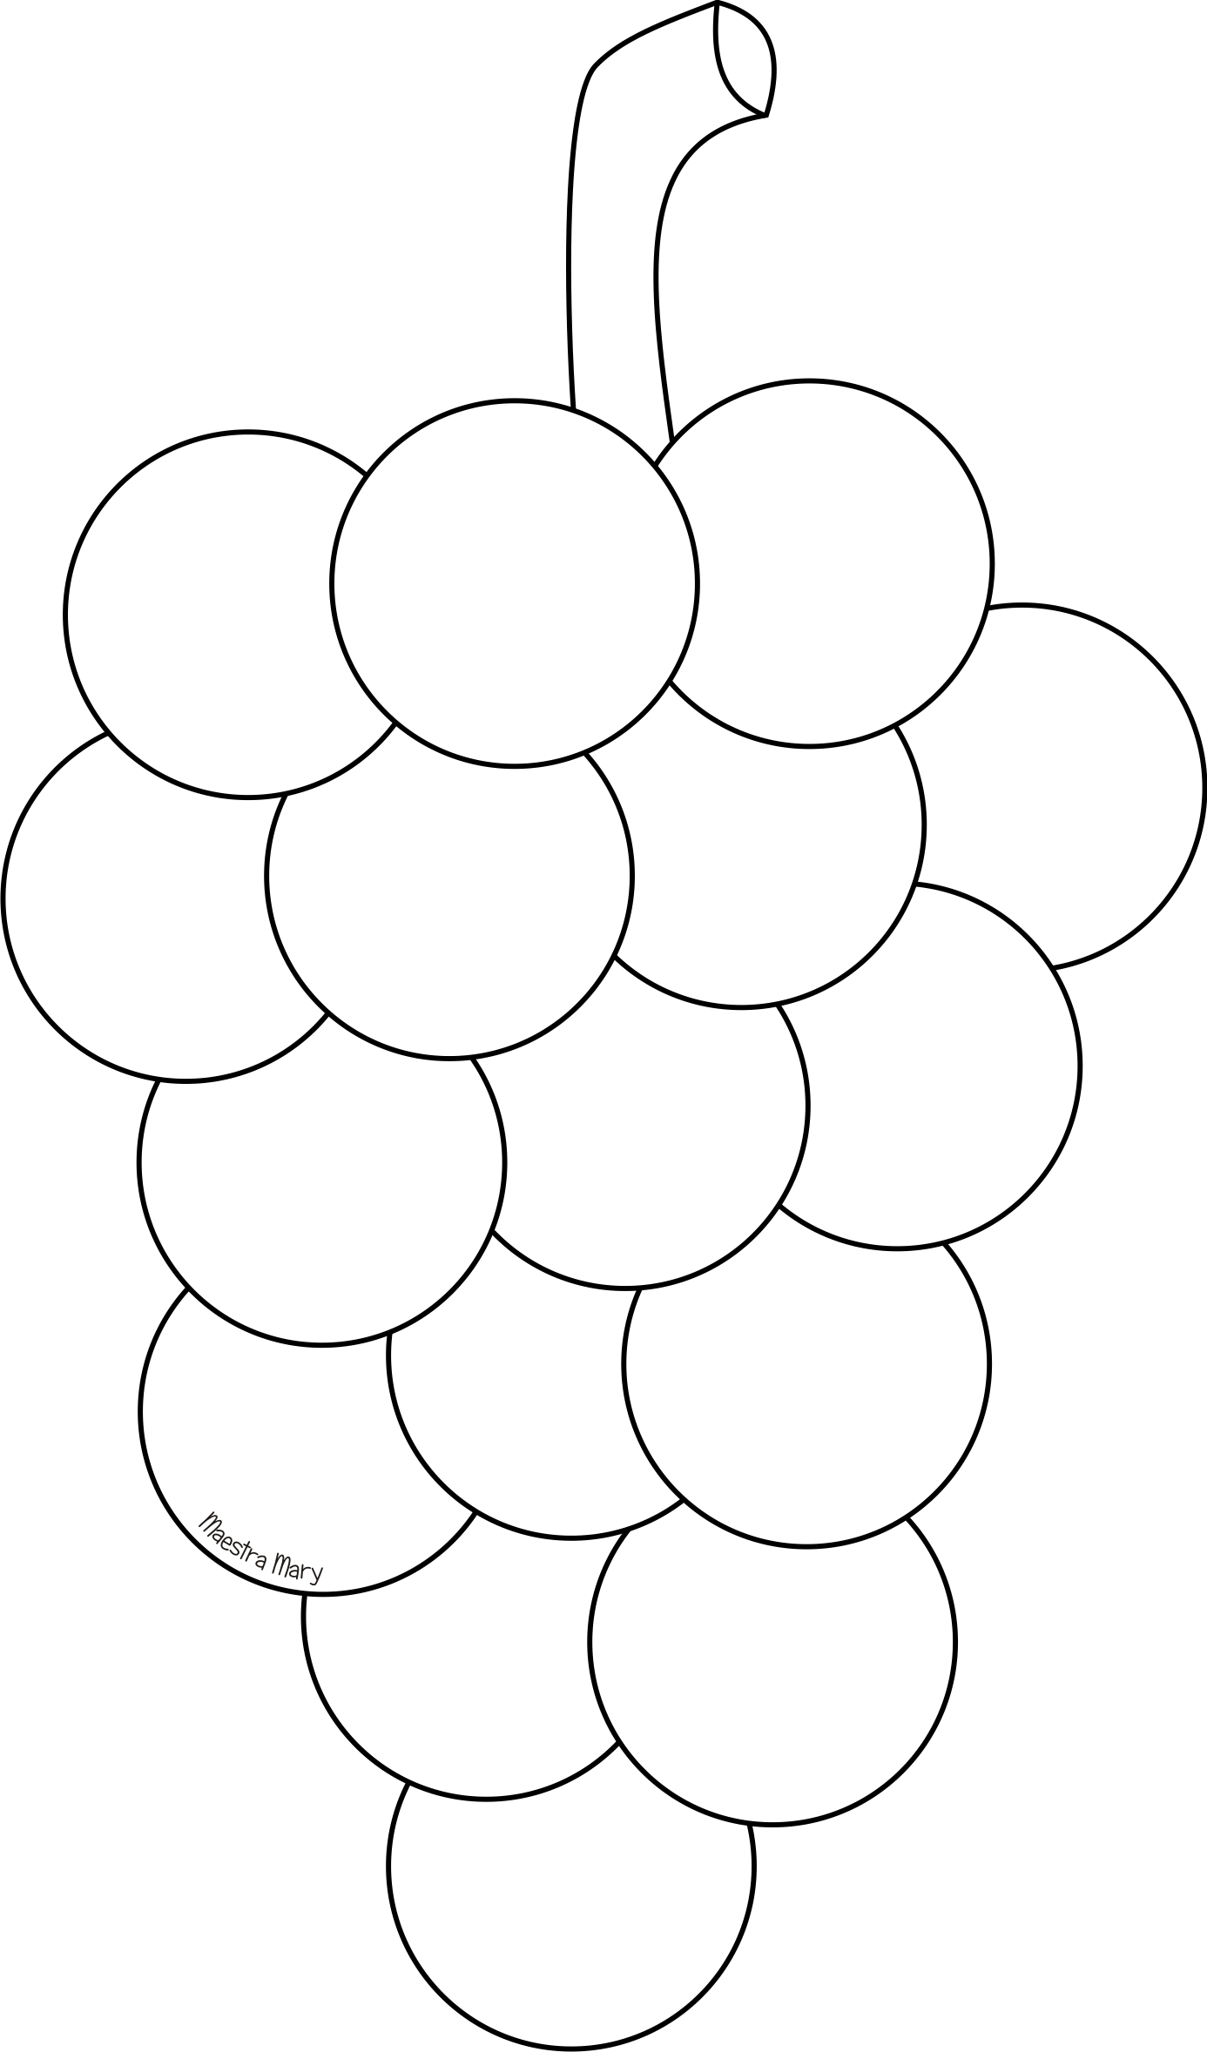](http://www.google.it/url?sa=i&rct=j&q=&esrc=s&source=images&cd=&cad=rja&uact=8&ved=0ahUKEwiQnM-ltN3PAhWMJhoKHdSCDKEQjRwIBw&url=http%3A%2F%2Fmaestramary.altervista.org%2Fautunno-sagome.htm&psig=AFQjCNEEJeNvLcNOIt3OtF9thFtfVbyB7g&ust=1476641470816287)