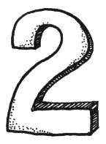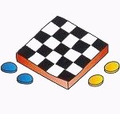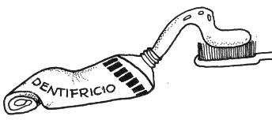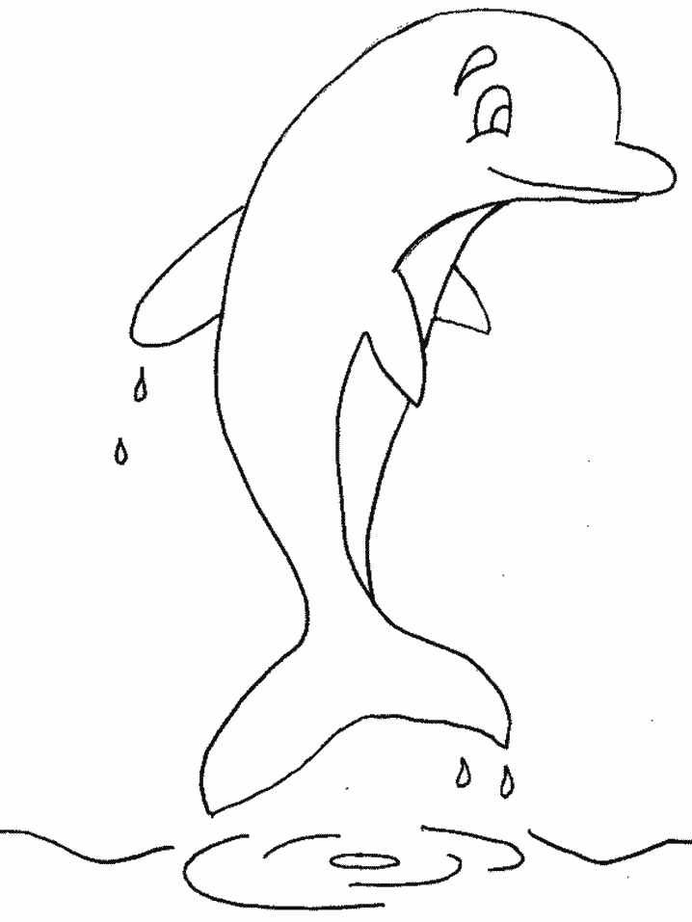

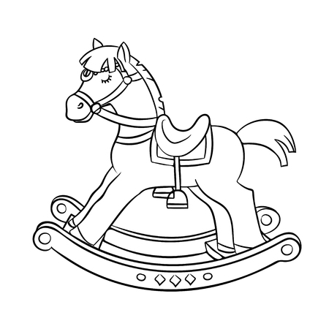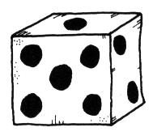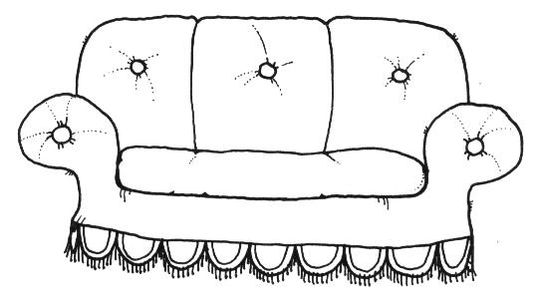

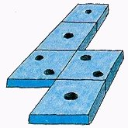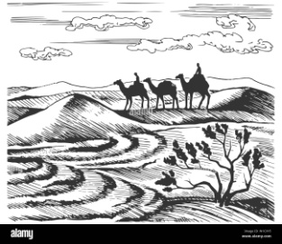

|  |  |  |  |  |  |  |  |  |
| --- | --- | --- | --- | --- | --- | --- | --- | --- |
|  |  | N | A |  |  | L | L | A |

|  |  |  |  |  |
| --- | --- | --- | --- | --- |
|  |  | N | T | E |

|  |  |  |  |  |  |
| --- | --- | --- | --- | --- | --- |
|  |  | M | I |  | O |

|  |  |  |  |
| --- | --- | --- | --- |
| A | L |  |  |

