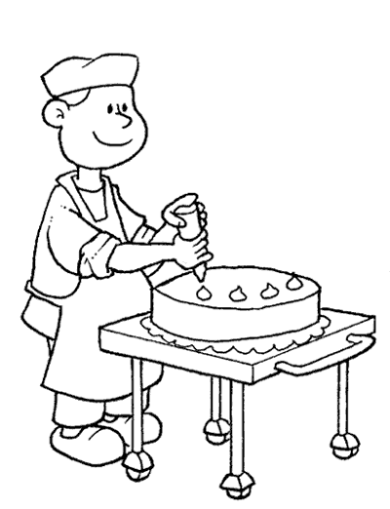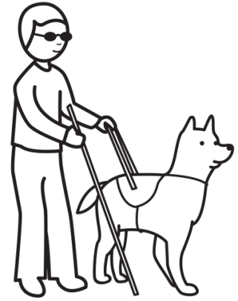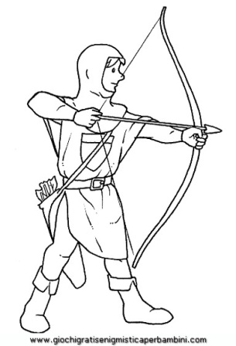

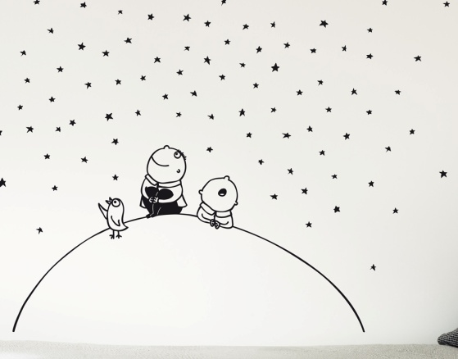[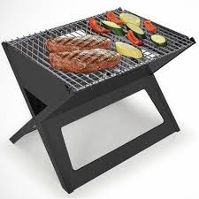](http://www.google.it/url?sa=i&rct=j&q=&esrc=s&source=images&cd=&cad=rja&uact=8&ved=0CAcQjRw&url=http://www.gerak.eu/prodotto-145417/Barbecue-Salvaspazio-Pieghevole-a-Carbone-Portatile-Braciere-46x-44-cm.aspx&ei=M8ZDVOnBL4ivPLW9gFg&psig=AFQjCNGs_hYE25keDSBy0yk5ioQHq0b2xg&ust=1413814169504998)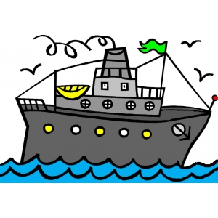

--------------------------------------------------------------------------------------------------------------------------------------------





[](http://www.google.it/url?sa=i&rct=j&q=&esrc=s&source=images&cd=&cad=rja&uact=8&ved=0CAcQjRw&url=http://www.gerak.eu/prodotto-145417/Barbecue-Salvaspazio-Pieghevole-a-Carbone-Portatile-Braciere-46x-44-cm.aspx&ei=M8ZDVOnBL4ivPLW9gFg&psig=AFQjCNGs_hYE25keDSBy0yk5ioQHq0b2xg&ust=1413814169504998)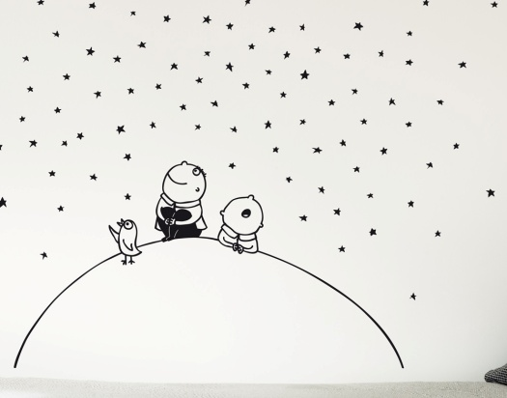



singolare plurale

pan-cia - CE

aca- cia - CIE

acacie

pance