GI + A GIA

GI + O  GIO

GI + U  GIU

------------------------------------------------------------------------------------------------------------------------------------

[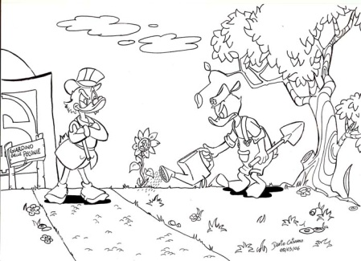](http://www.google.it/url?sa=i&rct=j&q=giardino+disegno&source=images&cd=&cad=rja&docid=MRf5voc541CtwM&tbnid=YIhwDlWU1giSGM:&ved=0CAUQjRw&url=http://www.luciano.gatto.name/Angolo_dei_visitatori/2_Dario/Zio%20Paperone%20e%20il%20Quinto%20sigillo.htm&ei=7SkzUeSeAcnRsgajjoDoDw&bvm=bv.43148975,d.Yms&psig=AFQjCNGruuqDgA-xuPoD4hagqbCgjyyYeQ&ust=1362393955751916)[](http://www.google.it/url?sa=i&rct=j&q=&esrc=s&frm=1&source=images&cd=&cad=rja&docid=EO3xMJ5UZgEYiM&tbnid=F7OAxmtH8agMmM:&ved=0CAUQjRw&url=http://www.maestramary.altervista.org/carnevale.htm&ei=iikzUbcvhIS0BvOlgKAL&bvm=bv.43148975,d.Yms&psig=AFQjCNFQ51H6zFx6GKNWdFUeGLdPXJMv-A&ust=1362393837304276)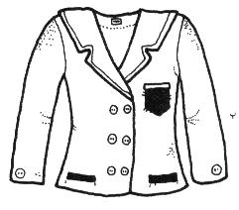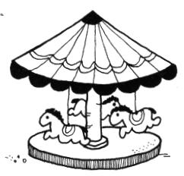

[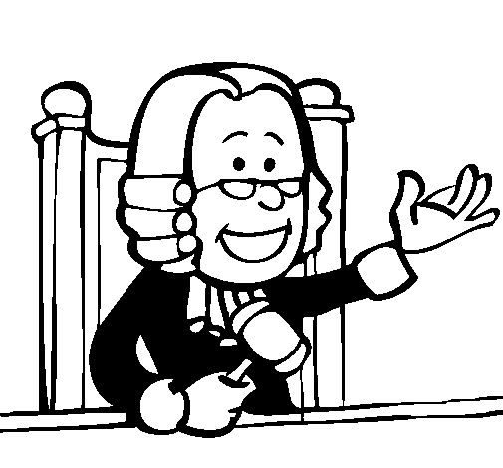](http://www.google.it/url?sa=i&rct=j&q=&esrc=s&frm=1&source=images&cd=&cad=rja&docid=xGRDtKRK-SPbuM&tbnid=dTkeX_kDwahSzM:&ved=0CAUQjRw&url=http://galleria.acolore.com/mestieri/altre-professioni/giudice-dipinto-da-nino-248818.html&ei=9yozUceKNY34sgbHt4CQAw&bvm=bv.43148975,d.Yms&psig=AFQjCNFJXiMneYF0cnhEaBB1jDXljWt4lA&ust=1362394228905650)[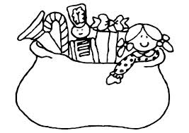](http://www.google.it/url?sa=i&rct=j&q=giocattoli+disegno&source=images&cd=&cad=rja&docid=e0yg4zAO38o1aM&tbnid=qq9i3iOGGtTwIM:&ved=0CAUQjRw&url=http://www.educolor.it/disegno-da-colorare-sacca-giocattoli-i8650.html&ei=OiozUd3vEIrctAbB0IDABw&bvm=bv.43148975,d.bGE&psig=AFQjCNF-fGCPtiofNSH6-bCaPB4wfZ-Ffw&ust=1362394027987636)

Completa le parole con GI – GE - GIA – GIO – GIU

valan___ * ___lato * ___fo * ___rilla * ___llo

___loso * ___rnale * ___ppetto * ____ngla

GI + A GIA

GI + O  GIO

GI + U  GIU

GI + A GIA

GI + O  GIO

GI + U  GIU

GI + A GIA

GI + O  GIO

GI + U  GIU