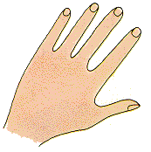

|  |  |  |  |  |
| --- | --- | --- | --- | --- |
|  |  |  |  |  |

|  |  |  |  |
| --- | --- | --- | --- |
|  |  |  |  |

|  |  |  |  |
| --- | --- | --- | --- |
|  |  |  |  |

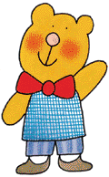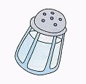

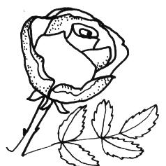

|  |  |  |  |
| --- | --- | --- | --- |
|  |  |  |  |

|  |  |  |  |
| --- | --- | --- | --- |
|  |  |  |  |

|  |  |  |  |
| --- | --- | --- | --- |
|  |  |  |  |

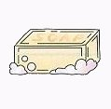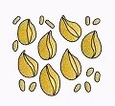

|  |  |  |  |
| --- | --- | --- | --- |
|  |  |  |  |

|  |  |  |  |  |  |
| --- | --- | --- | --- | --- | --- |
|  |  | P | O | N | E |

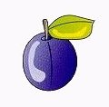



|  |  |  |  |  |  |
| --- | --- | --- | --- | --- | --- |
|  |  |  |  | N | A |

|  |  |  |  |  |  |
| --- | --- | --- | --- | --- | --- |
|  |  |  |  | N | A |

|  |  |  |  |  |
| --- | --- | --- | --- | --- |
|  |  | D | I | A |

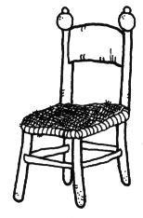

|  |  |  |  |
| --- | --- | --- | --- |
| M | O | R | A |

SCRIVI LA SILLABA CHE SENTI ALL’INIZIO DI OGNI PAROLA

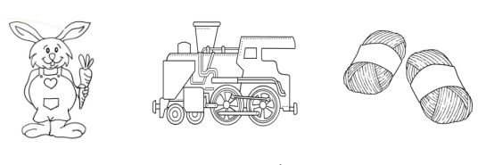

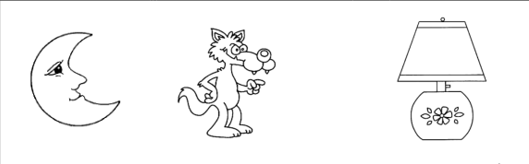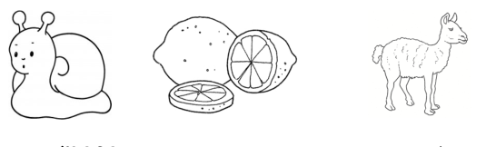

CERCHIA LA LE LI LO LU

MELA LAMA LIRA MELE LUNA MULO

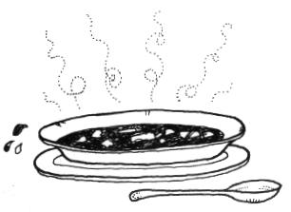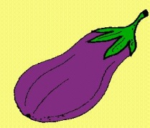

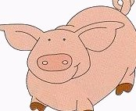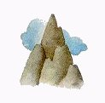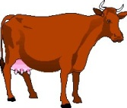

---------------------------------------------------------------

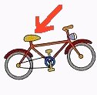COMPLETA CON LA SILLABA MANCANTE

___ ___ L E __ __ L L A

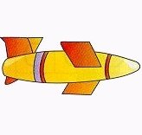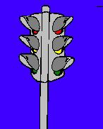 __ __ M A F O R O

__ __ L U R O



__ __ U G O