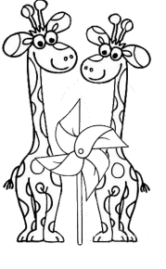

------------------------------------------------------------------------------------------------------------------------------------------
Scheda 2

